Marketing to Millennials
  - By: Jessica Jacovino
An explorative study of how companies need to change and evolve to the meet the growing demands of Millennials in an attempt to advertise to this ever-changing generation.
Table of Contents:

Table of Figures: 2
Executive Summary 3
Introduction 4
Literature Review 4
Hypotheses 9
Methodology 10
Focus Group 10
Professional Interviews 11
Survey 11
Results 11
Focus Group 11
Professional Interviews 15
Dan Schawbel 15
Lauren Davis 16
Victoria Caldwell 18
Survey 19
Discussion 28
Conclusion 30
Appendices 33
Survey 33
Survey Frequencies 38

Table of Figures:

Figure 1: Rate of TV Advertisement Recall 6
Figure 2: Brands Using Social Media 7
Figure 3: Millennial’s Preferred Method for Receiving Product Information 8
Figure 4: Millennials Want Companies To Entertain Them 9
Figure 5: Demographic of Participants 11
Figure 6: Exercise Results 12
Figure 7: Digital vs. Tradition Ads 20
Figure 8: Absence of Commercials 21
Figure 9: How Do Millennials Watch TV 22
Figure 10: Which Social Media Platforms Do Millennials Use? 22
Figure 11: Responding to Negative Comments, Millennial Responses 23
Figure 12: Responding to Negative Comments, Non-Millennial Responses 23
Figure 13: Tracking Online Activity 25
Figure 14: Paid Ads on Social Media 25
Figure 15: Millennials Using their Parents for Advice 26
Figure 16: Non-Millennials Using their Parents for Advice 26

Executive Summary
Today’s young adults are the most informed, confident and connected generation the world has ever seen. Generation Y, also known as the Millennials, is the largest generation yet—even bigger than the Baby Boomers. However, they are also the hardest generation for companies to advertise to, which poses a big problem for the future of marketing. Millennials, specifically, have become a growing focus for many companies as they represent a large buying power in the U.S. They represent a significant shift from the traditional to new and modern, making them a difficult generation to predict. The purpose of this study is to research how marketing to Millennials is different from marketing to past generations, and what are the most successful methods to connect companies to this emerging generation.
To study this I used various research methodologies including an explorative focus group with Bentley students, in-depth interviews with professionals working in the field of marketing and who have first-hand experience marketing to Millennials, and a large, random sample survey. In order to focus my research I applied many of my questions to the advertising of insurance companies as many Millennials currently are or will be in the market for this product making them a huge target market for the industry.
Compiling all of my research, I came up with several interesting and informative results about the Millennial generation. First, while many companies believe that TV advertisements are dying, Millennials still find that they still have the biggest impact and are the most engaging. Instead, it is the length of the TV ads and the medium through which they are receiving them that is changing. Second, Millennials rely on personal recommendations and word-of-mouth when making purchasing decisions, as opposed to advertisements or online reviews. Lastly, for companies to stand out to Millennials, they must be engaging and do something creative and innovative, and market to them in a way so that they don’t feel it is an advertisement.
This study has several implications for the insurance industry, as well as marketing in general, in relation to Millennials. Companies must make it a priority to create shorter and more shareable content that connects to this generation. While TV ads are the still the most engaging, they must also seek new ways to attract attention, such as through viral videos or other interactive advertising campaigns. Finally, they must learn to include the customer in the conversation and make their brand one for which Millennials will want to advocate.

Introduction
Today’s young adults are the most informed, confident and connected generation the world has ever seen. They have also never lived in a world without computers or the internet. Generation Y is the largest generation yet—even bigger than the Baby Boomers. However, they are also the hardest generation for companies to advertise to which poses a big problem for the future of marketing.
Millennials specifically have become a growing focus for many companies as they represent a large buying power in the U.S. despite their high unemployment rate. They represent a significant shift from the traditional to new and modern. They are not satisfied with the technology of yesterday and are always looking for the next big thing which can make it hard for companies to anticipate the best way to market to this finicky and quick-changing generation.
The purpose of this study is to research how marketing to Millennials is different than marketing to past generations and what are the most successful methods to connect companies and marketers to Millennials. I will look at the literature and studies currently available and, building off that, conduct my own primary research to draw conclusions about the future of advertising in the face of a new generation of consumers.

Literature Review
Today there is a plethora of literature that exists researching, defining and analyzing the Millennial generation which all present interesting theories and conclusions about this complex and evolving group of people. It is from this research that I will develop my own hypotheses and methods for studying the Millennial generation from a new perspective in order to draw innovative and valuable conclusions.
First, in order to understand and study Millennials, we must define what the Millennial generation is. To start, Millennial is a name commonly used to refer to Generation Y, because they are those that came of age in the beginning part of the new millennium, however, defining this generation is not so clear cut as one may believe. In Jeff Fromm and Christie Garton’s book, Marketing to Millennials, they define Millennials as anyone born between the years of 1977 and 1995, making the oldest millennials 37 and the youngest 18 years old. However, in a report published by ComScore, an American Internet analytics company, in which they studied the effectiveness of TV advertising on different generations, they defined Millennials as individuals born between 1981 and 2000 (33 to 13 years of age currently). Finally, a study by Edelman, one of the largest public relations firms, defined Millennials as people born between 1980 and 1995 (34 to 18 years old). In general though, it seems like the consensus is that those born in 1977 may be a little too old to fall into this category, so 1980 is around the time when the Millennial generation started. Also, those born in 2000 may be too young and might be part of a newer generation, Generation Z, which is similar to Millennials but may exhibit some distinct differences. Therefore, going forward in this research and analysis, Millennials will be categorized as individuals born around 1980 to 1995. One characteristic that all of the research agrees with is that the Millennial generation is the largest one yet, even bigger than the Baby Boomers. Their population is approximately 79 million in the United States alone, versus about only 48 million in the generation before them, Generation X, or 76 million in the Boomer generation. They will also soon have the strongest purchasing power of any generation with an estimated $170 billion per year.³ It is due to this vast size and expanding purchasing power that Millennials are becoming such an interest to companies and why it is important for them to understand this new consumer in order to evolve with their changing target market.
One major difference between Millennials and past generations is how they relate and react to advertisements. For starters, only 26 percent watch TV for 20 hours or more per week in comparison to the 49 percent of non-Millennials therefore, the TV advertisements are reaching less Millennials than non-Millennials immediately. Also, when Millennials are watching TV they are more likely to watch on their computers through streaming services (42 percent of Millennials versus 18 percent of non-Millennials).⁵ Also, in a six-month long global research study conducted by Mr. Youth, a marketing agency, and Intrepid, a research and consulting firm, it was found that only 17.7 percent of the Millennials studied agreed that their favorite TV spot led them to purchase the advertised product. They also found that Millennials are wary of ads and become more wary when they observe the product not living up to claims. In a 2011 study of 500,000 women across 4 generation groups—Millennials, Gen X, Baby Boomers and Seniors—they tested the effectiveness of TV advertising on the different groups. The study found that Millennials were the most difficult group to persuade using TV advertising and that they had a hard time even remembering the ads compared to other generations (see Figure 1). This was to be expected since Millennials often have a reputation for short attention spans and requiring more attention-grabbing content than other groups.³
In terms of using social media to connect with Millennials, the results are mixed. In a survey of over 400 U.S. Millennials in July 2013, 83 percent of respondents said that sponsored stories make their social media experience worse and that 67 percent of them never even click on a sponsored story. Sponsored stories are ads that companies can buy which are put directly into consumer’s social media feed instead of around it as most digital banner ads are. While this may be effective to older generations on social media who are unaware that these are paid advertisements, Millennials are all too aware that they are company ads and they avoid them without even realizing it.⁶ However, another study found that Millennials are far more likely than non-Millennials to favor brands and companies that have Facebook pages or mobile websites than companies that don’t (33 percent versus 17 percent).⁵ Another study found similar results and even found that Millennials like checking out brands on social media more than non-Millennials, and yet, Millennials also find brands on social media slightly more annoying which leaves us with slightly conflicting data (Figure 2).
Figure 1: Rate of TV Advertisement Recall
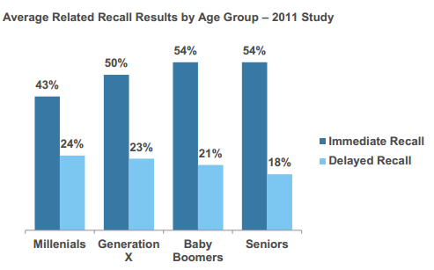

Figure 2: Brands Using Social Media
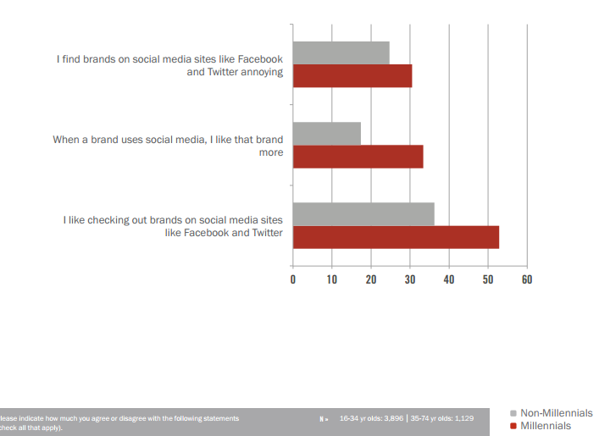
One clear characteristic that Millennials possess is that they are wary of ads, and, therefore, they get recommendations from friends, read reviews, post on social media and do online research in order to find the truth.⁷ In relation to digital advertising, a staggering 92 percent of Millennials in the survey reported that trust plays a large factor in who influences them online, yet only 6 percent consider online advertising to be credible.⁷ Therefore, the rest of the population has to be getting their information from a more trustworthy source. From the existing research, it seems that the number one resource that Millennials turn to when making a purchasing decision is their friends. In the SocialChorus survey, 95 percent of Millennials said that friends are the most credible source of product information and that 91 percent of them would consider purchasing a product if a friend recommended it.⁶ In Millennial Inc., word-of-mouth was ranked as the number one preferred place to receive news and information about products (43%) over TV and websites—26 and 22 percent respectively (Figure 3).⁷ Because of their skepticism and wariness of company ads, Millennials are turning to what they hear from friends, family and other trusted sources when making purchasing decisions. Therefore, the only way for companies to gain their trust is to deliver on their promises consistently and make consumers want to advocate for their brand.

Figure 3: Millennial’s Preferred Method for Receiving Product Information
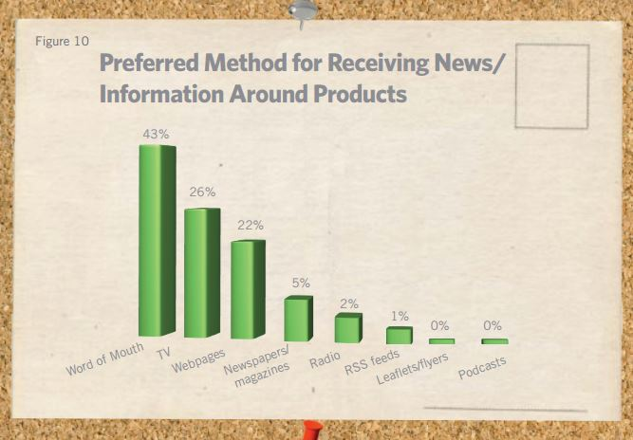
In conjunction with this, companies must also make consumers, particularly Millennial ones, participants in the product and interact with them as much as possible. In a comprehensive study of 4,000 Millennials in 11 countries, Edelman found out that 8 in every 10 Millennials expect brands to entertain them. The number one way that Millennials wanted companies to entertain them was to allow them to co-create their products (figure 4). They also expect more from companies when communicating with them. As figure 4 illustrates, 33 percent of the respondents expect companies to answer questions or comments in real time on social media.⁴ They event expect typically one-way communication like commercials to engage and invite them rather than push and persuade them as is normal for such advertisements.⁷ Millennials also expect to engage back with companies, through reviewing their product or service. In The Millennial Consumer: Debunking Stereotypes, the researchers determined that Millennials are more engaged online with 60 percent doing activities such as rating products and services versus the 46 percent of non-Millennials.⁵ Furthermore, through a survey of 2000 UK consumers, 55 percent of the Millennial respondents said that they use social media to vent about bad customer experiences compared to 35 percent of all of the respondents that answered thus. They use Facebook more than any other website and expect a response from the company. More than just wanting to give feedback, many Millennials feel it is their responsibility to share feedback with companies. Because Millennials use personal recommendations and word-of-mouth so frequently they expect that others are doing the same. In fact, 74 percent of the 4,000 Millennials surveyed said they believe they influence the purchasing decisions of those around them. Consequently, 72 percent of Millennials (global average) think it is their responsibility to share feedback, good or bad, with a company. While the U.S. numbers are slightly below this (67%) it still illustrates the point that Millennials can and will share their experiences with a company, good or bad, not only with their friends in person, but also, with companies and other customers online.⁴ Therefore, it is up to companies to not only respond to comments in a timely and effective manner, but also to improve their customer service overall, before and after the transaction, otherwise they will find themselves with a major problem among Millennials.
Figure 4: Millennials Want Companies To Entertain Them
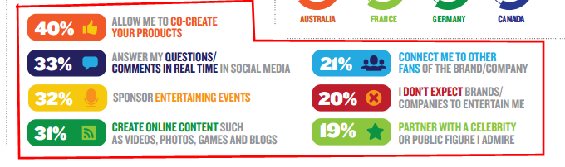

Hypotheses
Based off the findings of existing literature and research I have created the following hypotheses which I hope to test:
- The effectiveness of TV, print, and other more traditional methods of advertising are declining and digital advertising will become the more preferred method of communication with Millennials.

- Millennials will rely more on recommendations and word-of-mouth than company advertising when making purchasing decisions.

- Millennials will want and expect advertisements to be more creative and interactive in the future. Companies will not be able to remain stagnant.

- Companies will need to provide better and more individualized customer service to interest Millennials and retain them as customers.

Methodology
As part of the Capstone Project, I implemented various methods and tactics to perform primary research and determine what is the best way for companies to market to Millennials. In order to focus my research I chose to specifically look at how insurance companies can advertise to this generation and then applied those findings to a broader group. I chose to focus on insurance because most Millennials would understand and have some basic knowledge about the companies and they are at the age where they may have just purchased insurance or will be in the near future. Therefore, the advertisements are targeted heavily at them and the results of my research would most apply to these sorts of companies.

Focus Group
To gain a preliminary perspective which would then be applied to a larger group, I selected a sample of Bentley students to participate in an intensive focus group to determine their attitudes and behaviors in respect to insurance advertisements, as well as, advertisements as a whole. The focus group had 6 participants—2 male, 4 female—and was conducted and recorded in the Center for Marketing Technology lab at Bentley. In the focus group, participants were asked to think of insurance companies and insurance ad campaigns unprompted and then prompted. They were also shown different car insurance companies’ print and TV advertisements and asked to compare and contrast. The focus group also highlighted their feelings on companies using social media, online reviews, and word-of-mouth. Overall, the focus group served to concentrate my research and target what type of questions to ask going forward.

Professional Interviews
Having researched the perspective of college Millennials, I decided to get a more professional viewpoint of Millennials who had already left home and college and are currently in the workforce to look for any similarities or inconsistencies between the two groups. One such interview was with Dan Schawbel, a Bentley alumnus who has devoted his post-grad work to studying and informing the professional world about the Millennial generation. He is the managing partner of Millennial Branding, a Gen Y research and consulting firm, has published two books, Promote Yourself and Me 2.0 which both deal with Millennials in the work place. As such, I found him to be a very informed expert on the subject and was able to ask him a wide variety of questions to get his professional opinion.
I also interviewed other Bentley alumni who are currently working in marketing and who also happen to fall into the Millennial generation. By doing this I was able to get both their professional and personal perspectives on the subject.

Survey
As a final way to apply my hypotheses and research to a large population, I conducted an online survey which asked a variety of questions about their advertising preferences and their opinions on marketing to their own generation. I distributed the survey though email and social media so as to get a wide range of participants. The survey was completed by 64 individuals whose ages ranged from 12 to 75+.

Results

Focus Group
The focus group was comprised of 6 Bentley University students—2 males, 4 females—all 21 or 22 years of age, from varying home states and varying majors (Figure 5).
Figure 5: Demographic of Participants
Participant Name | Hometown | Age | Major
Lacey Nemergut | Hillboro, NJ | 22 | EcoFi
Briana Wolff | Southington, CT | 22 | CIS
Jill Weiss | Poughkeepsie, NY | 22 | EcoFi
Cesar Pellerano | Miami Lakes, FL | 22 | EcoFi
Sydney Bouchard | Shelborn, VT | 21 | Marketing
Derek Bressler | Hopkington, MA | 22 | Marketing

As an opening exercise, participants were asked to write down as many insurance companies as they could think of in 30 seconds and afterwards they were asked to write down as many car insurance companies they could think of in 30 seconds. Some said that they were able to name more the second time simply because they had more time to think of companies. However, others said that by adding “car” insurance as a prerequisite it made them include less in the second list because they weren’t sure that the insurance companies they had used in the first list sold car insurance specifically. Participants were then asked to write down as many car insurance ad campaigns they could think of in 1 minute. Participants were purposefully not told how to identify the campaigns in order to see how they would identify them. Once they were done they were asked to count up how many they were able to think of and share how they identified the different campaigns. Jill said that she grouped ads together by the slogans used. Cesar, on the other hand, thought of the spokesperson in the commercial and used that as his standard for grouping. Figure 6 shows the results from the first 3 unprompted exercises.
For a prompted exercise, participants this time were prompted with pictures of popular car insurance spokesmen and asked to match them to their insurance company. For this exercise, 4 of the 6 participants were able to correctly identify all 6 spokespersons. Those 4 agreed that it was easier to think of the insurance companies when they were prompted with the visual rather than trying to recall from memory. Jill disagreed and said that it was easier to think of her own companies rather than trying to connect faces to companies. Sydney agreed with her and added that some insurance companies like Allstate, State Farm, and Farmers blend together because they don’t stand out the way Progressive or Geico do.
Figure 6: Exercise Results
Name | Insurance Companies | Car Insurance Companies | Ad Campaigns
Lacey | 6 | 6 | 7
Briana | 6 | 4 | 7
Jill | 8 | 4 | 5
Cesar | 6 | 6 | 5
Sydney | 6 | 8 | 8
Derek | 6 | 5 | 4

The next part of the focus group concentrated on comparing and contrasting print and TV advertisements. Participants were first shown 4 print advertisements from popular magazines such as GQ and People. They then observed 5 TV commercials and were asked to compare and contrast. Overall, the group was uninterested with the print advertisements and only commented that the Progressive and Geico ads used prominent figures so they were able to easily identify them but that the State Farm one was not as recognizable. For the TV ads, the participants were shown a short Progressive ad featuring their spokesman “Flo”, a Geico “Gecko” ad, the viral Geico Hump Day ad, and two State Farm ads using the “Like a Good Neighbor” slogan in real life and in a Scooby Doo cartoon version. Some overarching opinions seemed to focus around the idea that the advertisements and spokespersons are merely being shown to remind us of the company and that they don’t have to be informative because we already know what they do. They also said that they preferred funny, viral videos over informational ones. Similarly, they agreed that State Farm using Scooby Doo was a good decision because it connected them with a nostalgic feeling that a lot of people, especially Millennials, would feel towards the cartoon.
As a contrast to the more traditional ads, the participants were shown a video of an interactive ad campaign that Traveler’s had done in some airports; they displayed a series of screens that interacted with people as they walked by. All of the participants really liked the idea of the interactive ad and said that it would catch their attention. Their only concern was that if you didn’t know the company well there wasn’t enough brand information so that consumers would connect the ad to the company. Derek said, “People are so inundated with ads that it's just nice that there's feedback to the way you interact with it so there's some interaction there. I think that especially our generation, because we're online so much, we see a lot of additional ads that maybe other generations don't so this just might be a way to get it to stand out to us in particular." In general, the group seemed to respond positively to the idea of interactive ads and found them new and creative.
In terms of companies using social media to advertise, the group had mixed feelings. While most of them said they would not follow a company on social media unless they drew them in, they conceded that it would be weird for a large company to not have a social media presence. They also said they would not use the company’s social media for information but that they could use their pages to post entertaining content which their followers may enjoy. They decided there was a limit to how much companies should post and if they are posting excessively it can get annoying and actually turn customers off. On the topic of companies using social media to engage with their customers, everyone established that it does the company more harm than good because most large companies will constantly have people posting about their negative experiences, which can deter prospective customers. Nevertheless, companies can take advantage of the situation and show that they care about their customers and providing good customer service by responding to the damaging comments and taking steps to correct the problem. There’s not much that companies can do about the negative comments so the best they can do is to control the damage by providing good customer service.
The conversation then turned towards online reviews of companies and word-of-mouth. When asked what route they would go through if looking to buy car insurance, most of them said they would do their own research online and then rely on recommendations from parents and friends. Many agreed that their friends would be important and useful to ask because they would be in a similar category. Briana said, “I would definitely go to my friends because they're in the same spot as I am. They're in the same age bracket and graduating from college and in some ways the same financial area that I am in so I would definitely go to them for advice." Lacey also added she would, “trust them [friends] more than ads or social media.” In dealing with online reviews, the whole group agreed that they would not rely on them for a big purchase like insurance because they are often one-sided. However, they might look at an overall rating or consumer reports which take out some of the overall bias. Looking at online purchases as a whole, the group said that they would use online reviews for goods or to gain more information about what they are purchasing that may not be available up front but that they wouldn’t rely on reviews for information about services or purchases that are more tailored to the individual experience.
On the subject of advertising to Millennials as a whole, participants had opinions not only on the types of ads they want to see, but also, advertising as a whole. Lacey answered, “I think we’re so flooded with them [ads] that now it’s really hard to get someone’s attention with them…we’re just so bombarded with them that it’s hard for one to stand out in my head.” Derek said that ads will get his attention more if they are comedic but in order for an ad to be persuasive to him it has to do a hard comparison of their product versus the competitors. On the other hand, Cesar and Jill said that they would prefer for ads to tell them information about something that directly benefits them or something that is new and they wouldn’t already know about.
Their opinions on Millennials’ attitudes about advertising stayed focused around the same idea of skepticism and cynicism. Lacey said, “I think that we might be more skeptical because we've seen all these ads and been promised all these things that it's hard to see these ads and determine what should we listen to, what shouldn't we listen to. So I think a lot of weight goes to what are the people around you doing." Derek added to this: “I think there's a lot of advertising cynicism in our generation because we see all these claims, but I think that going forward the ads have to turn into the content and become the content themselves. We really have to be entertained and informed for them to get our attention and have an effect at this point." These feelings were echoed by the rest of the group. In terms of celebrity endorsements, most of the participants said that they are useful for advertisements when there is a relevant connection between the product being endorsed and the celebrity. Jill also added that the best endorsements for companies are if celebrities endorse the product and use it without being paid.
Comparing digital ads versus TV advertisements, the majority of the group alleged that they actually notice TV ads more than digital ones because they either mentally block them out or they use an ad blocker that does it for them. Derek noted that he believes Hulu has the best model for ads because they only show commercials for a shortened amount of time so there’s not much time to do anything else so people are actually forced to watch the commercials. Lacey added that we grew up with TV commercials so they are more acceptable to us and we expect them to be there.
Finally, participants were asked what they thought was the best way for companies to reach Millennials. Sydney said that online videos that are more content than advertisements are the one that catch her attention. Derek agreed with this and said, “I really think if a company wants to have an effective advertising it has to be content on its own. People tune out the noise so companies need to make the advertisements noise that people want to hear.” Briana said that to get our attention, ads should be funny or entertaining instead of informative because there are so many ways that we can look up information ourselves. Lastly, Lacey added that anyway a company can get more word-of-mouth is the best advertisement to her because she would be more inclined to listen to what a friend has to say rather than a company advertisement.

Professional Interviews

Dan Schawbel
Dan Schawbel is a 2006 Bentley University alumnus who has dedicated his post-grad life to studying and informing people about Millennials, personal branding and workplace trends. He is the managing partner of Millennial Branding, a Gen Y research and consulting firm. He has also written two bestselling books about personal branding and Millennials in the workplace. In addition to is the founder of the Personal Branding Blog and writes columns for both TIME and Forbes. He is an expert on Millennials and answered some questions I created based off of my initial research.
To start, I asked Dan if he thought traditional advertising had any effect on Millennials anymore or if Millennials simply tune them all out. He said that TV is still the medium with the biggest impact on Millennials, even more than digital ads. He also added that, “Millennials want something more custom. Ads need to be short, sweet and memorable, as well as, in their language.” However, he did admit that a lot of Millennials are skipping commercials and do whatever they can to avoid them which is why he thinks targeting is so important when trying to reach your target customer. He said, “These days, you just can’t buy a banner ad; you need to target the right audience and to just throw advertisements at random customers.” He also said that companies need to create content that is very shareable and catchy and that they need to put the content where their audience is.
I also explained to him the aversion many of the focus group respondents had to online reviews. He disagreed, however, with their assertion that they don’t use them to assess a company. He explained that reviews are the only data out there about a company so when they need information they will use reviews. He then agreed that parents are big influencers for Millennials and that’s where a lot of them go for information. He also agreed with the group that people are much more skeptical of advertisements than in the past. He said, “People in general don’t trust ads as much as they used to. Therefore, companies need to be honest about the story behind their company and the reasons behind everything they do. Honesty has to be ingrained in their company’s values.”
In looking specifically at the content of advertisements he echoed a popular opinion in the group which was that ads should be informative only if they educate the consumers on something they don’t already know. He also asserted that interaction will be a major advantage for companies going forward. He said, “Everything has to be 2-way advertising and not just with Millennials. If you’re not doing it, someone else is.” In relation to this, he also said that customer service will become increasingly important for Millennials: “Bad reviews are always going to happen but customer service can be a competitive edge for a company. If companies have the resources they should be interacting with customers in real time to provide them the best customer service.”

Lauren Davis
Lauren Davis is a 2013 Bentley undergrad alumnus and is currently pursuing a degree from Bentley’s Professional MBA Program. She is also working at Keds as the Creative Services Coordinator. As she is a Millennial herself and is working in marketing for a brand targeted towards younger shoppers I decided she would be useful in my study of marketing to Millennials.
As with Dan, I first asked Lauren if she thought that traditional advertisement has any effect on Millennials. She answered that they do have some effect but that they are probably less impactful than digital ads such as banner ads, mobile ads, etc. because it is easy to tune them out and Millennials do so without even thinking about it. She also said that in order for them to evolve and remain relevant they must become interactive in some way, whether through a QR code or some call to action, in order to encourage customers to make the next step towards purchasing. She also agrees with Dan in that commercials are more effective in a shortened format like that of Hulu rather than traditional TV commercial breaks. She said, “For shortened ads on sites like Hulu, there are typically only 1-3 ads playing and since you are likely watching on a mobile device or a laptop, you are less inclined to go do something else and are not able to simply fast forward. However, it is easy to open up a social media site when the commercial is on and can then ignore the commercial all together.”
I also asked her how she felt about online reviews versus word-of-mouth, referring to the focus group where many of the participants said they don’t trust online reviews for something as important as buying insurance or some other services. She agreed with them saying, “I find that reviews online are often very extreme – people either had a great experience with a product or they hated everything about it. It’s hard to find any reviews that fall in-between and that seem more honest.” Lauren also asserted that we as Millennials are over the traditional marketing that older generations are used to and that we want exciting and if an advertisement is something new and different we are more likely to check it out. She also said that advertisements should be more funny or entertaining than informational and that companies should also be wary of including certain information: “Companies do need to be cautious of what they state as we do have a wealth of information at our fingertips – it is so easy to prove a company wrong if they provide misinformation.”
Turning to the subject of companies using social media and how Millennials interact with them, Lauren believed that the Millennial generation is much more likely to share feedback, especially through social media because we want instant gratification and because it is so easy to share and recommend (or not) companies to friends and families on social channels. She also asserted that because of this, Millennials want companies to interact and create 2-way communication with them: “If they [companies] don’t [interact with Millennials], they will likely lose that customer to their competitor who shows that they care about what the customer thinks. Our generation wants instant gratification and companies must recognize this.” However, she also recognizes that social media can have negative impacts as well as positive on a company. Lauren said, “I think that social media can be a double edge sword – it is easy for people to see a bad review which could impact purchasing decisions, but it is then a great opportunity for the brand to comment back and offer a solution or reimbursement. This shows that the company cares and has great customer service.”
Finally, I asked her what she felt is the best way for companies to reach Millennials so that they are interested and don’t tune them out. She responded that companies need to interact with us and target their advertisements to their customers: “They [companies] need to find out what their target person is interested in and show them something that relates to that in a new and exciting way. This could be a funny, entertaining, or inspirational video, or some sort of game to play during an ad. I have seen a lot of these on Hulu and they are kind of fun!” Overall, she agreed that companies need to put more effort into identifying their customers and advertising to them based on their wants and needs.

Victoria Caldwell
Victoria Caldwell is 2012 Bentley undergrad alumnus who majored in Marketing and IDCC. She is currently working as a Sales Consultant for a media monitoring firm in Boston. As she majored in marketing and currently works in sales, and also is a Millennial herself, she seemed like an ideal person to talk with about marketing to Millennials.
In regards to traditional ads, Victoria takes a more optimistic view than some of the other interviewees. She believes that they can still be effective and that a creative ad with a clear message can be very effective in advertising to Millennials and those companies don’t have to necessarily use digital ads. She also takes a different stance on regular TV commercial breaks versus shortened formats online. She thinks that we expect ads on our TVs since they’ve always been there but when we’re online we’re anxious for them to end so we resent them more. This theory was also echoed in the focus group by a participant who believed that we are more accepting of TV ads because we grew up with them.
Focusing on online reviews, Victoria agreed with what the focus group had said about social media. She said, “I still trust online reviews for certain things, but obviously online content needs to be taken with a grain of salt. I trust my family and friends reviews over things a lot more than a stranger in the internet. I agree that the bigger the investment, the more I will rely on word of mouth.” She also said that for her personally, she relies on her parents for advice about decisions which she doesn’t know much about such as retirement plans, filing taxes, insurance, etc.
When I asked her if she thinks Millennials are advertised out, she agreed that we might be overwhelmed with ads, but that it’s also the only thing we’ve ever known so we are accustomed to them. As far as advertising strategies, she believes that companies that can blend information and entertainment together in equal parts are very successful: “A company that comes to mind immediately in this realm is E*TRADE. In their commercials I learn about their offerings, while almost always smiling and laughing at the talking baby.”
Next I asked her about social media and how companies and customers interact using it. Victoria said that she thinks it is important for companies to have a social media presence because it is a sign that they are legitimate and a modern company that can keep up with the times. She also agrees that while negative posts can hurt a company, customers will find a way to post their feelings either way regardless of whether a company has a page or not. She said, “To combat negative side effects a company needs to be constantly monitoring what takes place and respond accordingly.”
Finally, I asked her what she thinks is the best way for companies to reach Millennials and break through all the noise. One of her ideas was social media interaction because Millennials especially love to be acknowledged by a company. She also thinks that lowering the price for new customers and using a referral system works well. She said, “I think Uber does an excellent job at this. Not only is your first ride $10 off, but if you share your code with a friend who is new to using the app, they get $10 off and you get another $10 off as well once they take their first ride.”

Survey
My survey had a total of 64 participants, 11 male and 53 female. Of those participants, 47 were within the defined Millennial age range of 18 to 34. The participants were asked 26 questions with various parts about topics that I had discussed and researched though the focus group and professional interviews.
After the demographic questions, which were used to get a better understanding of the respondent’s makeup, I began by asking them if they notice traditional advertisements such as magazine, billboard, and radio ads. A surprising majority (46%) answered that they notice them most of the time with a minority answering that they barely ever or never notice them. I then went further and asked them how effective (very effective to very ineffective) they found traditional ads in the following categories: informative, funny, engaging, persuasive and entertaining. Of all the respondents, the characteristic that was ranked the highest was informative with persuasive being the lowest category though the difference between each of the categories in between was not very great.
Another question produced surprising results then I asked respondents if they notice digital ads (emails, banner ads, social media ads) more than traditional advertisements. Looking at all the respondents, over half (52%) answered probably not or definitely not. Of just the Millennials even more (55%) answered in the previous way (Figure 7).
Figure 7: Digital vs. Tradition Ads

Because there had been such a mixed reaction to TV advertisements in the focus group and through the interviews, I decided to look at how customers see are getting their commercials, if at all, and how they react to them. As this is mostly pertaining to Millennials, all of the following figures will be taken only from the Millennial respondents. I first looked at what paid TV and movie streaming services respondents used to understand if they were even seeing advertisements when watching their programs. Only 12 of the 47 said that they don’t pay for any TV streaming service. Over 60% answered that they subscribe to Netflix, a streaming service that does not make viewers watch commercials. Only 6 respondents answered that they subscribe to Hulu Plus which is the only streaming service that forces customers to watch commercials even when they are paying for the premium service. However, of the 6 respondents that said they subscribe to Hulu, all of them answered that they enjoyed the shortened format of the commercials better than regular commercial breaks that they would see when watching traditional TV.
Respondents were also asked if the absence of commercials was a part of their decision to purchase these subscription services over other ones. Of the 33 respondents that said they subscribe to Netflix or Amazon, 69% said that answered probably yes or definitely yes (Figure 2). Additionally, the respondents who answered that they do not pay for any streaming service were asked how they watch TV programming. These responses were more varied but the majority said that they watch regular TV (Figure 8). In terms of how often Millennial respondents watch regular TV for an extended period of time the responses were pretty evenly split across the answers of daily, 2-3 times a week, once a week, 2-3 times a month, once a month, or less than once a month which leads us to believe that some Millennials are still watching but others are not. For comparison, non-Millennial respondents answered that they watch much more frequently with 50% answering that they watch TV daily and another 25% saying that they watch TV 2-3 times a week. Also, the majority of Millennials (46%) answered that they rarely pay attention to commercials when watching regular TV with the next most popular answer being sometimes (36%). Similarly, the two most popular answers for non-Millennials was also rarely and sometimes with 38 percent each, respectively. It is interesting to note that none of the non-Millennials answered they always pay attention to commercials, while 1 of the Millennial respondents did answer in this way.
Figure 8: Absence of Commercials

Figure 9: How Do Millennials Watch TV

The next group of questions focused on social media and how respondents interacted with companies using it. As expected, all Millennials were active on some type of social media with Facebook having the overwhelming majority with 96% of the respondents; all of the other social media sites besides Google+ had a good response as well (Figure 10). When prompted how likely they would be to follow or like a company, Millennial respondents answered that they would be most likely to like companies on Facebook than any of the other platforms. The other companies were ranked as follows: LinkedIn, Twitter, Instagram, Pinterest, and Google+.
Figure 10: Which Social Media Platforms Do Millennials Use?

When asked how likely respondents would be to share a negative experience with a company on social media the Millennial answers were very evenly distributed with a slight tendency towards more unlikely than likely, though it was not a very significant difference. Nevertheless, the majority answered positively that it definitely or probably helps a company when they respond to negative comments on their social media pages (Figure 11). For comparisons sake, non-Millennial respondents also felt similarly as is shown in Figure 12. This could be indicative of a change in what all consumers expect from companies and their customer service.
Figure 11: Responding to Negative Comments, Millennial Responses

Figure 12: Responding to Negative Comments, Non-Millennial Responses

The number of respondents who think companies help their reputation by responding to comments on their social media pages jumps significantly when you cross-reference against people that would be more likely to like or follow a company on social media. Of the 21 respondents who answered they would be very likely to follow or like a company on at least one of the social media choices, 62 percent said that it definitely helps a company’s reputation and an overwhelming, 81 percent answered positively. This indicates that respondents, who are more likely to follow a company on social media, also place a larger stake on companies providing good customer service through social media.
By using social media, companies also have the opportunity to use paid advertisements and gain more information about their audience. However, this can lead to problems with their customers who don’t want advertisements in their social media or who want more privacy. When asked how they felt about companies paying to place targeted ads on their social media page the two most popular answers were that they are ineffective and that the respondents don’t notice them. Only 9 of the 47 Millennials said that they found them useful and persuasive. Additionally, when asked how they feel about web browsers and companies tracking their online activity to tailor ads, the most popular answer was that respondents would prefer for their online activity to not be tracked (53%) with the second most popular answer being that respondents feel it is an invasion of privacy. Only 8 Millennial respondents said that they don’t mind being tracked because they would prefer ads tailored to them personally. In comparison, non-Millennials had the same opinions except that “invasion of privacy” was the most popular and “prefer to not be tracked” was the second most popular answer.
Additionally, of the 11 Millennial participants who responded that they answered that companies placing paid advertisements on their social media was an “invasion of privacy”, 82 percent felt that companies and browsers tracking their online activity was also an “invasion of privacy” and that they would “prefer not to be tracked at all” (Figure 13). Even more noteworthy, however, was that some of the 11 participants also answered that they found paid advertisements on social media invasive, also answered that they were an “appropriate for of advertising” and that they are “useful and persuasive” (Figure 14). This either indicates that respondents recognized that they are an invasion of their privacy but feel it’s an appropriate and useful tool for companies in today’s society, or they did not entirely understand the question.

Figure 13: Tracking Online Activity

Figure 14: Paid Ads on Social Media

To study how Millennials make purchasing decisions respondents were asked how much they use the following tactics: company ads, word-of-mouth, recommendations, online reviews, and independent research. Unsurprisingly, the tactic that Millennials used the most was recommendations from family and friends with word-of-mouth as a close second. Company ads were by far the least used. This was also the same for non-Millennial participants. An overwhelming majority of Millennials (92%) also answered positively that they would be likely or very likely to go to their parents for advice about purchasing decisions (Figure 15). Also, none of the Millennial respondents said that they would be very unlikely to go to their parents. Comparatively, the non-Millennial respondents were much more varied with the majority answering that they would be unlikely or very unlikely (Figure 16) though this may be more indicative of non-Millennial respondents being older, and therefore, less likely to go to their parents for that reason rather than valuing their opinion less.
Figure 15: Millennials Using their Parents for Advice

Figure 16: Non-Millennials Using their Parents for Advice

Additionally, I wanted to specifically look at how Millennials respond to online reviews since there were mixed opinions on the subject. When asked how often they felt online reviews were trustworthy, useful, informative and a good representation of the company/product most of the responses were “often” or “sometimes” and the mean values were all very similar and only off by one or two points, except for “a good representation of the company” which was ranked lower than the other options. This means that overall, Millennial respondents found online reviews to often be trustworthy, useful and informative, and they sometimes felt it was a good representation of the company/product. Respondents were also asked to rank characteristics they value in effective advertisements. The characteristics were funny, interactive, engaging, informative, entertaining and emotional. Of these choices, a majority of Millennials said that funny was the most important characteristic. The other choices followed in this order: informative, entertaining, engaging, interactive and emotional. Also, when questioned which form of advertising they found most engaging, over half of the respondents answered that TV advertising was the most engaging. The other advertisements were chosen as follows: print ads, radio ads, paid social media ads, billboards, email ads, online banner ads, and in-person ads (flyers, brochures, etc.).
Finally, respondents were allowed to openly write what they believe is the best way for companies to advertise to Millennials. Obviously, there were plenty of varied responses but the most popular one, by far, was social media. Many other responses included TV ads and digital ads; however, most respondents said that they just wanted companies to be different and creative. One respondent said, “Anything that is interactive online engages a Millennial. Traditional advertising is ignored and social media advertising is as well. I, for instance, use an ad blocker so that I don't even see them.” Another respondent answered, “I think for something to really stand out against the plethora of other advertisements we see on daily basis it really needs to be something that is different, and that gets people talking but is still related to the product.”

Discussion
This study has integrated the use of existing literature with primary research through the use of a focus group, interviews with professionals in the marketing field, and a comprehensive survey of Millennials and non-Millennials. These different sources of information have produced a plethora of material and theories, some that have correspond and others that contradict which makes it important to weigh the source of the information and determine which information can be used as facts and which need to be explored further.
One fact that became clear through the primary research, which is supported by existing literature, is that Millennials are most reliant on recommendations from family and friends and word-of-mouth when making purchasing decisions. Many of the existing research I came across mentioned that word-of-mouth was important to Millennials which inspired my further exploration into this theory. This also became apparent in my own research which first became apparent in the focus group when many of the participants said they would use those methods most when purchasing insurance. This was then supported by the professional interviews when all of the interviewees agreed that Millennials are particularly willing to give and receive recommendations, especially through social media. Finally, this was confirmed in the survey when participants were asked what tools they use when making a purchasing decision and the number one and two choices were recommendations and word-of-mouth. This is unsurprising since Millennials are by far the most connected generation the world has ever known so they are more likely to seek information from their connections rather than from a company or third-party.
Building off of this, Millennials rely on their parents for advice in purchase decisions more than previous generations. While none of the secondary research specifically pointed to this as a previously studied idea, the primary research proved that it was certainly a promising theory. When participants in the focus group were asked how they would go about buying car insurance for the first time, many indicated that they would go to their parents due to their inexperience in the subject. Dan Schawbel echoed this as well and went as far as to say that parents are the biggest influencer for Millennials. Additionally, in the survey, almost all of the Millennial respondents (92%) answered that they would definitely or probably go to their parents for advice in a purchasing decision. On the other hand, almost 60 percent of the non-Millennial respondents answered that they probably or definitely would not go to their parents for advice.
A more contested point was whether TV advertising is still relevant and effective to Millennials. Much of the research—both primary and secondary—agreed that Millennials are watching a significant less amount of TV than previous generations and that when they do it is online. About 75 percent of the Millennial survey respondents said that they subscribe to a TV streaming service. Also when asked how often they watch regular TV the answers were varied and there was no clear trend or leader. Additionally, in the secondary research, one of the studies found that Millennials are the most difficult generation to persuade using TV ads and that they even have a hard time remembering them, possibly because they are so inundated with advertisements. On the other hand, many of the participants in the focus group indicated that they notice TV ads more than other type of advertisements, specifically digital ads such as banner ads or paid social media ads. Many of the professionals also agreed with this assertion on the caveat that Millennials want commercials to be in shortened formats, like on Hulu or YouTube. This notion was supported in the survey as all of the respondents who said they pay for a Hulu Plus subscription enjoy the shortened format of the commercials over traditional commercial breaks. Therefore, this may indicate that TV advertisements are still effective, but that the medium through which Millennials are receiving them has changed.
In association with this, digital advertising is also a gray area in the research, specifically social media. Millennials in both the focus group and survey agreed that it would be strange for a company to not have a social media presence, however, they also said that they would probably not actively seek out companies to follow and that companies posting on social media can be annoying and, if done too often, actually turn them off from that brand or product. In this case, the existing literature is not entirely clear whether advertising online is useful or noticed by Millennials. In the same survey, they found that Millennials were more likely than non-Millennials to interact and favor brands with a social media presence yet, they were also more likely to find brands on social media annoying. Looking specifically at companies using digital and social media ads, it was pretty clear that Millennials found these methods completely ineffective. The focus group’s overall response was that they ignore digital ads and that some even block them purposefully. Additionally, in the survey, Millennial respondents were asked whether they notice digital ads more than TV ads and 55 percent answered probably not or definitely not. Also, paid social media posts was ranked the 4th most effective advertising method behind TV, print and radio and online banner ads were second to last. However, when respondents were asked what the best way for companies to advertise to Millennials is, a vast majority said social media. This could indicate a confusion of what exactly constitutes a digital ad versus a social media advertisement or it could be Millennials not realizing what they want from companies.
One use for social media that was agreed to be very important for Millennials, was the ability to interact with brands and companies, specifically to provide feedback on their experiences. In the existing literature Millennials indicated that not only do they want to give companies feedback publicly, they feel it is their responsibility. This plays back into the fact that Millennials rely on word-of-mouth for purchasing decisions so they think it is important to share what they know with others. The research also supported the idea that customers, specifically Millennials, expect more from companies in customer service and communication, especially on social media. They expect to be acknowledged and have some kind of action take place. In the focus group, the participants said that this can be a positive for a company’s reputation because customers will post negative comments, regardless of whether they have a social media presence, so they should take advantage of their opportunity to address their customers’ concerns and provide good customer service for all of their followers to see.
There were some overarching themes and concepts that were mentioned or supported in some way throughout the research. One of these ideas was that advertisements need to be different, creative and interactive in some way to be effective in capturing Millennials’ attention. Many of the participants in the focus group, interviews, and survey expressed that they think Millennials are so bombarded with advertisements that it’s hard for companies to break through and so being different and bold is the only way to get your message out. Another common point was that Millennials don’t trust advertisements, yet trust is a huge component of who they decide to purchase products from. Therefore, it is important for companies to be transparent about their product and not make promises or claims that they can’t live up to since Millennials have such a wealth of knowledge at their fingertips which can be used to disprove advertisements easily. Finally, because Millennials are so used to tuning out advertisements, using customer targeting is more important than ever. It is not just enough for companies to throw advertisements everywhere and at everyone. They must understand not only what Millennials want, but also where they are and how is the best way to get the advertisement to them or they will fail.

Conclusion
This research has provided us with a few very specific conclusions and recommendations for companies when targeting Millennials as a whole. First, my original hypothesis—the effectiveness of TV, print and other traditional advertising methods are declining and digital advertising will become the preferred method among Millennials—was disproven. TV advertising is still effective, just not in the traditional sense. Millennials have moved online when watching TV and companies must do the same with their advertisements. They must also work to provide shortened and more entertaining content than traditional TV commercials or they will simply be ignored online as well.
My second hypothesis, that Millennials will rely on recommendations and word-of-mouth more when marking purchasing decisions, was proven true. Throughout the entire study Millennials indicated that this was their number one source when making a purchasing decision over advertising or even researching. For Millennials, it’s all about what people say about a product and brand that determines whether they buy something because they trust their friends or even acquaintances more than companies and advertisements. What this means for companies is that they should take some of the money that they would use for advertising and instead innovate ways to make millennials want to be their brand advocates. In today’s society, companies will find a much larger return on investing in their customers rather than spending money advertising to them. Additionally, companies should consider that Millennials refer to their parents quite a lot when making purchasing decisions, especially for products they are unfamiliar with. Therefore, they might benefit from creating better relationships with the parents as well, as they can be a company’s biggest supporter when trying to gain Millennial customers.
When companies do advertise to customers, they must make the advertisements different and bold in order to stand out from the competition. As the research has shown, Millennials are over-flooded with advertisements every day and they have become very good at blocking them out either mentally or literally or simply avoiding them altogether. Therefore, it is up to companies to make their advertisements into content that customers feel is different and that they will want to share with others.
My final hypothesis deals with companies providing better and more individualized customer service to Millennials. This is definitely true of Millennials and may also be applied to the population as a whole. Because customers have the ability to comment or complain to a company immediately through social media platforms, they also expect companies to respond in real time and to interact with them about their specific problem. It is also important for companies to expect this of themselves because customer service is such a crucial factor in how customers feel about your company. If a company provides poor customer service to one Millennial, by the end of the week they will probably have lost more like 5-10 Millennial customers, due to the importance Millennials place on recommendations. Therefore, companies need to be aware of what people are saying about them and do everything in their power to rectify negative situations for the customer.
In conclusion, there is a way to advertise to Millennials, it is just not the way that companies are used to. Instead of spending large amounts of money producing twenty different ads using the same spokesman or jingle, companies should go out and film a flash-mob and post it to their social media page. When they do create advertisements they should be videos that are short, funny and engaging. Company advertisements need to be actual content that Millennials not only find appealing, but also, that they so want to share with other people. They should also focus on their customer’s individual experience, whether this is by providing good customer service in-stores with sales associates, online with free shipping both ways, or on social media after a negative experience. Each Millennial should, and will expect, to get great customer service or else they will find another company and take not only their business, but plenty of their family and friends with them. Finally, companies need to be innovative and creative when marketing to Millennials. While an advertisement may work once, using it over and over again will not appeal to the masses, most especially Millennials, so they will need to find something else to reach their target market. It used to be that companies could simply follow the leader and they would do relatively well, but in today’s fast-paced, technology-driven society, if you’re doing what you used to do, then you’re doing it wrong.

Appendices

Survey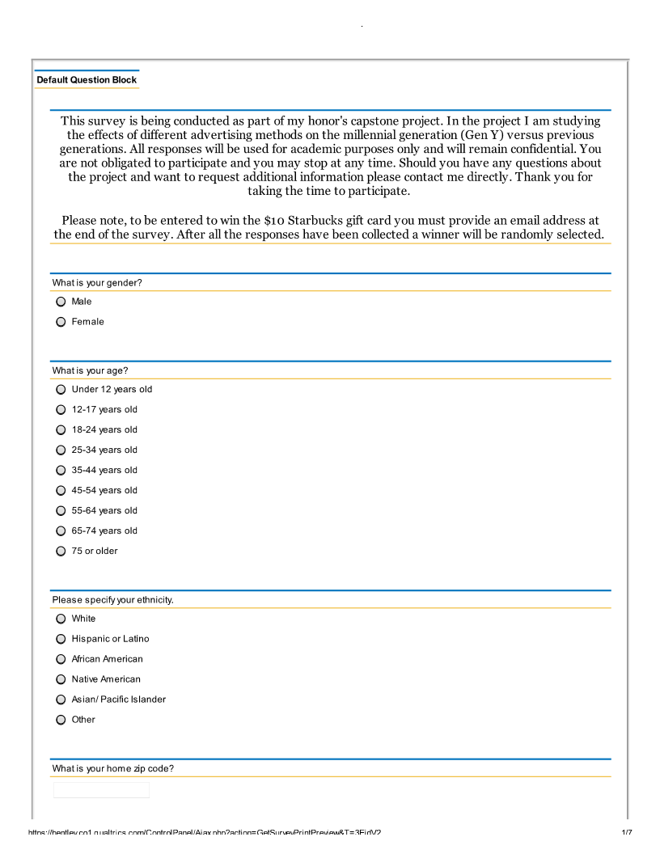
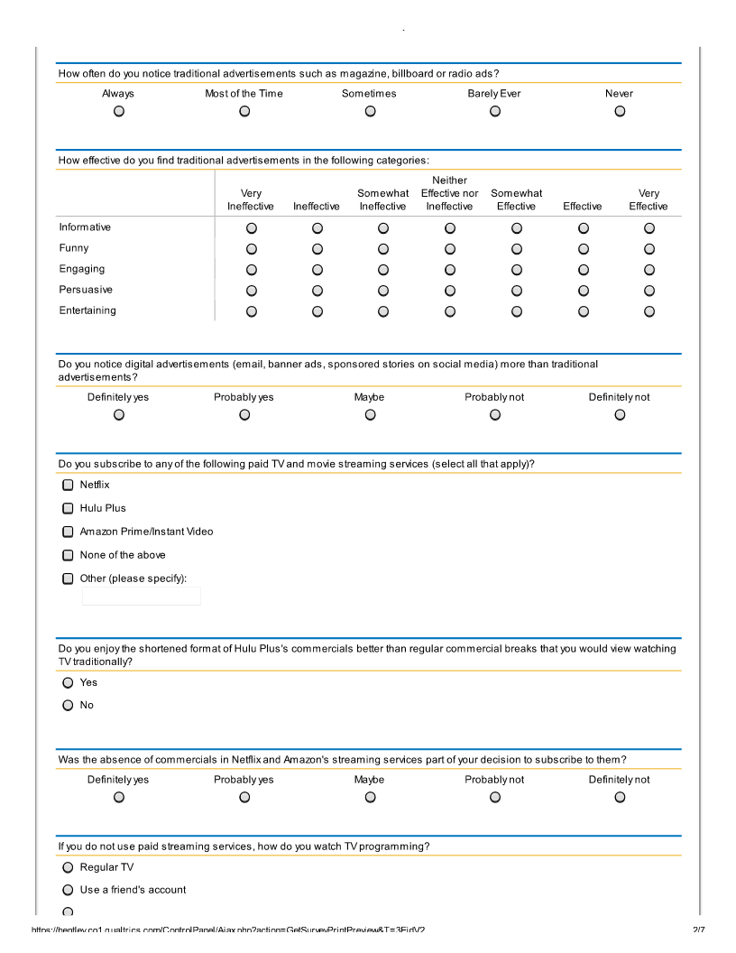
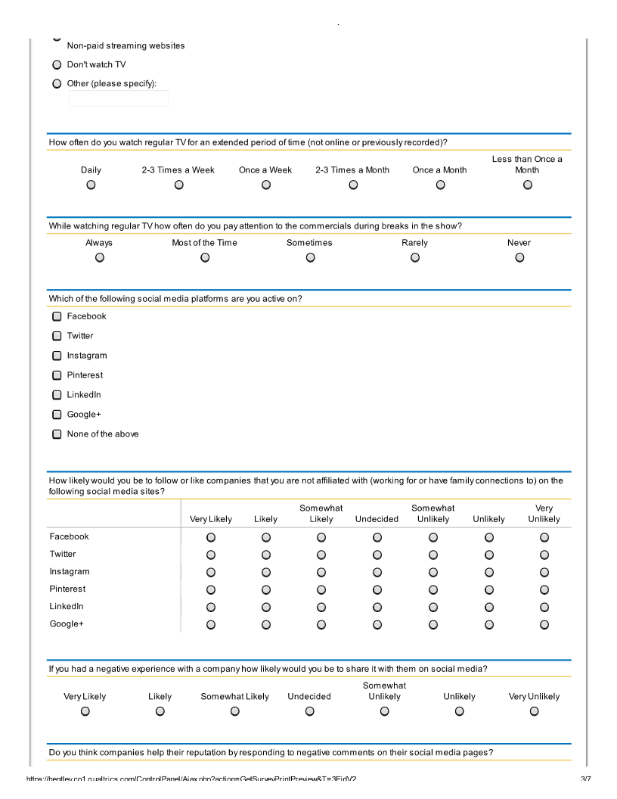
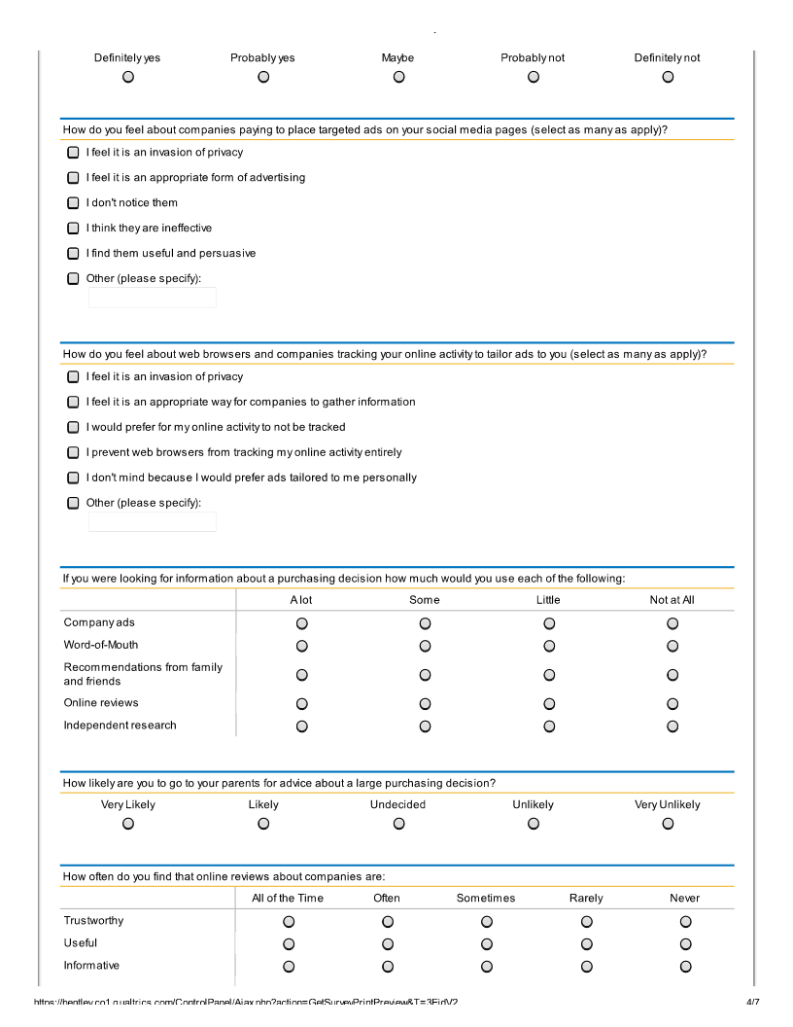
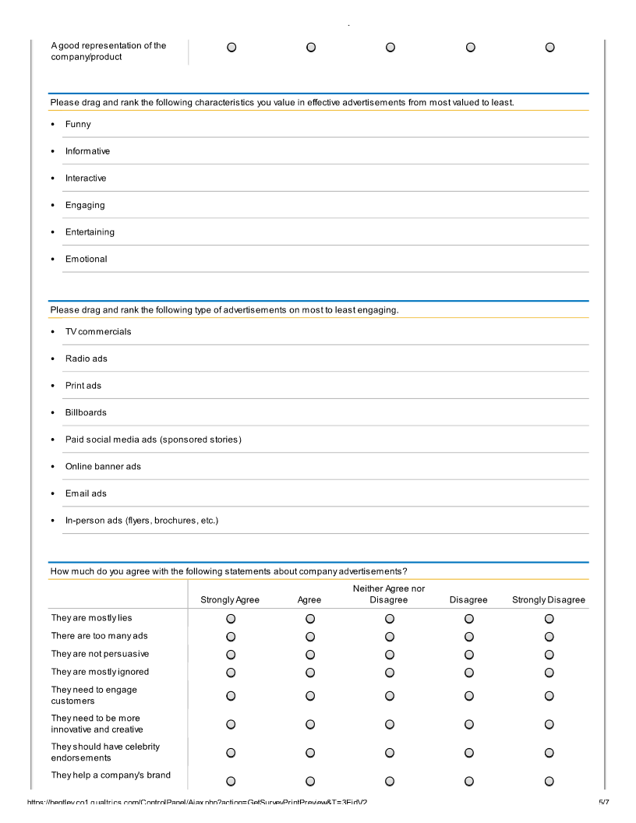

Survey Frequencies
Completed Surveys
Last Modified: 04/08/2014
Completion Status: Completed
1. What is your gender?
# | Answer |  | Response | %
1 | Male |  | 11 | 17%
2 | Female |  | 53 | 83%
 | Total |  | 64 | 100%

Statistic | Value
Min Value | 1
Max Value | 2
Mean | 1.83
Variance | 0.14
Standard Deviation | 0.38
Total Responses | 64

2. What is your age?

# | Answer |  | Response | %
1 | Under 12 years old |  | 0 | 0%
2 | 12-17 years old |  | 2 | 3%
3 | 18-24 years old |  | 44 | 70%
4 | 25-34 years old |  | 3 | 5%
5 | 35-44 years old |  | 2 | 3%
6 | 45-54 years old |  | 10 | 16%
7 | 55-64 years old |  | 1 | 2%
8 | 65-74 years old |  | 0 | 0%
9 | 75 or older |  | 1 | 2%
 | Total |  | 63 | 100%

Statistic | Value
Min Value | 2
Max Value | 9
Mean | 3.71
Variance | 1.98
Standard Deviation | 1.41
Total Responses | 63

3. Please specify your ethnicity.
# | Answer |  | Response | %
1 | White |  | 58 | 92%
2 | Hispanic or Latino |  | 2 | 3%
3 | African American |  | 1 | 2%
4 | Native American |  | 0 | 0%
5 | Asian/ Pacific Islander |  | 2 | 3%
6 | Other |  | 0 | 0%
 | Total |  | 63 | 100%

Statistic | Value
Min Value | 1
Max Value | 5
Mean | 1.19
Variance | 0.58
Standard Deviation | 0.76
Total Responses | 63

4. What is your home zip code?
Text Response
06712
02452
14223
90016
06611
06468
06468
12603
01844
06117
06489
06511
21133
10506
05482
06851
02839
06010
03106
03304
02478
01748
06468
06468
06468
34109
06614
06611
08844
06468
60543
06468
01880
06468
02169
06614
01803
02664
03801
02668
06060
02322
01002
02532
02421
33326
10591
02478
06825
40223
92024
12603
02852
11901
02136
02364
60134
01863
06468
01776
55438
06468
02452

Statistic | Value
Total Responses | 63

5. How often do you notice traditional advertisements such as magazine, billboard or radio ads?

# | Answer |  | Response | %
1 | Always |  | 6 | 10%
2 | Most of the Time |  | 29 | 46%
3 | Sometimes |  | 19 | 30%
4 | Barely Ever |  | 8 | 13%
5 | Never |  | 1 | 2%
 | Total |  | 63 | 100%

Statistic | Value
Min Value | 1
Max Value | 5
Mean | 2.51
Variance | 0.80
Standard Deviation | 0.90
Total Responses | 63

6. How effective do you find traditional advertisements in the following categories:
# | Question | Very Ineffective | Ineffective | Somewhat Ineffective | Neither Effective nor Ineffective | Somewhat Effective | Effective | Very Effective | Total Responses | Mean
1 | Informative | 1 | 8 | 7 | 2 | 24 | 18 | 3 | 63 | 4.68
2 | Funny | 5 | 11 | 4 | 5 | 11 | 18 | 9 | 63 | 4.52
3 | Engaging | 4 | 10 | 7 | 11 | 14 | 13 | 4 | 63 | 4.21
4 | Persuasive | 3 | 10 | 9 | 11 | 19 | 8 | 3 | 63 | 4.10
5 | Entertaining | 5 | 5 | 10 | 5 | 11 | 20 | 7 | 63 | 4.59

Statistic | Informative | Funny | Engaging | Persuasive | Entertaining
Min Value | 1 | 1 | 1 | 1 | 1
Max Value | 7 | 7 | 7 | 7 | 7
Mean | 4.68 | 4.52 | 4.21 | 4.10 | 4.59
Variance | 2.28 | 3.87 | 2.94 | 2.47 | 3.34
Standard Deviation | 1.51 | 1.97 | 1.71 | 1.57 | 1.83
Total Responses | 63 | 63 | 63 | 63 | 63

7. Do you notice digital advertisements (email, banner ads, sponsored stories on social media) more than traditional advertisements?

# | Answer |  | Response | %
1 | Definitely yes |  | 10 | 16%
2 | Probably yes |  | 12 | 19%
3 | Maybe |  | 8 | 13%
4 | Probably not |  | 22 | 35%
5 | Definitely not |  | 11 | 17%
 | Total |  | 63 | 100%

Statistic | Value
Min Value | 1
Max Value | 5
Mean | 3.19
Variance | 1.87
Standard Deviation | 1.37
Total Responses | 63

8. Do you subscribe to any of the following paid TV and movie streaming services (select all that apply)?

# | Answer |  | Response | %
1 | Netflix |  | 38 | 60%
2 | Hulu Plus |  | 12 | 19%
3 | Amazon Prime/Instant Video |  | 15 | 24%
4 | None of the above |  | 16 | 25%
5 | Other (please specify): |  | 2 | 3%

Other (please specify):
HBO to go
I borrow my friends accounts

Statistic | Value
Min Value | 1
Max Value | 5
Total Responses | 63

9. Do you enjoy the shortened format of Hulu Plus's commercials better than regular commercial breaks that you would view watching TV traditionally?
# | Answer |  | Response | %
1 | Yes |  | 11 | 92%
2 | No |  | 1 | 8%
 | Total |  | 12 | 100%

Statistic | Value
Min Value | 1
Max Value | 2
Mean | 1.08
Variance | 0.08
Standard Deviation | 0.29
Total Responses | 12

10. Was the absence of commercials in Netflix and Amazon's streaming services part of your decision to subscribe to them?

# | Answer |  | Response | %
1 | Definitely yes |  | 15 | 37%
2 | Probably yes |  | 13 | 32%
3 | Maybe |  | 5 | 12%
4 | Probably not |  | 6 | 15%
5 | Definitely not |  | 2 | 5%
 | Total |  | 41 | 100%

Statistic | Value
Min Value | 1
Max Value | 5
Mean | 2.20
Variance | 1.51
Standard Deviation | 1.23
Total Responses | 41

11. If you do not use paid streaming services, how do you watch TV programming?
# | Answer |  | Response | %
1 | Regular TV |  | 9 | 56%
2 | Use a friend's account |  | 1 | 6%
3 | Non-paid streaming websites |  | 3 | 19%
4 | Don't watch TV |  | 2 | 13%
5 | Other (please specify): |  | 1 | 6%
 | Total |  | 16 | 100%

Other (please specify):
dish

Statistic | Value
Min Value | 1
Max Value | 5
Mean | 2.06
Variance | 1.93
Standard Deviation | 1.39
Total Responses | 16

12. How often do you watch regular TV for an extended period of time (not online or previously recorded)?

# | Answer |  | Response | %
1 | Daily |  | 17 | 27%
2 | 2-3 Times a Week |  | 14 | 22%
3 | Once a Week |  | 10 | 16%
4 | 2-3 Times a Month |  | 8 | 13%
5 | Once a Month |  | 6 | 10%
6 | Less than Once a Month |  | 8 | 13%
 | Total |  | 63 | 100%

Statistic | Value
Min Value | 1
Max Value | 6
Mean | 2.94
Variance | 3.00
Standard Deviation | 1.73
Total Responses | 63

13. While watching regular TV how often do you pay attention to the commercials during breaks in the show?
# | Answer |  | Response | %
1 | Always |  | 1 | 2%
2 | Most of the Time |  | 4 | 10%
3 | Sometimes |  | 15 | 37%
4 | Rarely |  | 18 | 44%
5 | Never |  | 3 | 7%
 | Total |  | 41 | 100%

Statistic | Value
Min Value | 1
Max Value | 5
Mean | 3.44
Variance | 0.75
Standard Deviation | 0.87
Total Responses | 41

14. Which of the following social media platforms are you active on?
# | Answer |  | Response | %
1 | Facebook |  | 60 | 95%
2 | Twitter |  | 36 | 57%
3 | Instagram |  | 34 | 54%
4 | Pinterest |  | 26 | 41%
5 | LinkedIn |  | 38 | 60%
6 | Google+ |  | 5 | 8%
7 | None of the above |  | 1 | 2%

Statistic | Value
Min Value | 1
Max Value | 7
Total Responses | 63

15. How likely would you be to follow or like companies that you are not affiliated with (working for or have family connections to) on the following social media sites?
# | Question | Very Likely | Likely | Somewhat Likely | Undecided | Somewhat Unlikely | Unlikely | Very Unlikely | Total Responses | Mean
1 | Facebook | 13 | 17 | 20 | 1 | 3 | 6 | 3 | 63 | 2.90
2 | Twitter | 10 | 12 | 9 | 6 | 5 | 6 | 15 | 63 | 3.98
3 | Instagram | 6 | 12 | 11 | 3 | 4 | 7 | 20 | 63 | 4.40
4 | Pinterest | 9 | 5 | 14 | 6 | 7 | 5 | 17 | 63 | 4.27
5 | LinkedIn | 10 | 13 | 10 | 8 | 3 | 6 | 13 | 63 | 3.81
6 | Google+ | 4 | 2 | 7 | 14 | 5 | 6 | 25 | 63 | 5.10

Statistic | Facebook | Twitter | Instagram | Pinterest | LinkedIn | Google+
Min Value | 1 | 1 | 1 | 1 | 1 | 1
Max Value | 7 | 7 | 7 | 7 | 7 | 7
Mean | 2.90 | 3.98 | 4.40 | 4.27 | 3.81 | 5.10
Variance | 2.96 | 5.02 | 5.08 | 4.68 | 4.74 | 3.70
Standard Deviation | 1.72 | 2.24 | 2.25 | 2.16 | 2.18 | 1.92
Total Responses | 63 | 63 | 63 | 63 | 63 | 63

16. If you had a negative experience with a company how likely would you be to share it with them on social media?
# | Answer |  | Response | %
1 | Very Likely |  | 6 | 10%
2 | Likely |  | 7 | 11%
3 | Somewhat Likely |  | 13 | 21%
4 | Undecided |  | 7 | 11%
5 | Somewhat Unlikely |  | 11 | 17%
6 | Unlikely |  | 10 | 16%
7 | Very Unlikely |  | 9 | 14%
 | Total |  | 63 | 100%

Statistic | Value
Min Value | 1
Max Value | 7
Mean | 4.21
Variance | 3.62
Standard Deviation | 1.90
Total Responses | 63

17. Do you think companies help their reputation by responding to negative comments on their social media pages?

# | Answer |  | Response | %
1 | Definitely yes |  | 24 | 38%
2 | Probably yes |  | 16 | 25%
3 | Maybe |  | 12 | 19%
4 | Probably not |  | 9 | 14%
5 | Definitely not |  | 2 | 3%
 | Total |  | 63 | 100%

Statistic | Value
Min Value | 1
Max Value | 5
Mean | 2.19
Variance | 1.41
Standard Deviation | 1.19
Total Responses | 63

18. How do you feel about companies paying to place targeted ads on your social media pages (select as many as apply)?
# | Answer |  | Response | %
1 | I feel it is an invasion of privacy |  | 15 | 24%
2 | I feel it is an appropriate form of advertising |  | 19 | 30%
3 | I don't notice them |  | 25 | 40%
4 | I think they are ineffective |  | 24 | 38%
5 | I find them useful and persuasive |  | 10 | 16%
6 | Other (please specify): |  | 1 | 2%

Other (please specify):
i find it annoying

Statistic | Value
Min Value | 1
Max Value | 6
Total Responses | 63

19. How do you feel about web browsers and companies tracking your online activity to tailor ads to you (select as many as apply)?
# | Answer |  | Response | %
1 | I feel it is an invasion of privacy |  | 31 | 49%
2 | I feel it is an appropriate way for companies to gather information |  | 17 | 27%
3 | I would prefer for my online activity to not be tracked |  | 30 | 48%
4 | I prevent web browsers from tracking my online activity entirely |  | 2 | 3%
5 | I don't mind because I would prefer ads tailored to me personally |  | 9 | 14%
6 | Other (please specify): |  | 2 | 3%

Other (please specify):
I've accepted it. I don't think about it.
I wish we had the option of choosing if they could track us or not

Statistic | Value
Min Value | 1
Max Value | 6
Total Responses | 63

20. If you were looking for information about a purchasing decision how much would you use each of the following:

# | Question | A lot | Some | Little | Not at All | Total Responses | Mean
1 | Company ads | 5 | 22 | 30 | 6 | 63 | 2.59
2 | Word-of-Mouth | 41 | 17 | 5 | 0 | 63 | 1.43
3 | Recommendations from family and friends | 51 | 8 | 4 | 0 | 63 | 1.25
4 | Online reviews | 27 | 27 | 7 | 2 | 63 | 1.75
5 | Independent research | 27 | 22 | 12 | 2 | 63 | 1.83

Statistic | Company ads | Word-of-Mouth | Recommendations from family and friends | Online reviews | Independent research
Min Value | 1 | 1 | 1 | 1 | 1
Max Value | 4 | 3 | 3 | 4 | 4
Mean | 2.59 | 1.43 | 1.25 | 1.75 | 1.83
Variance | 0.60 | 0.41 | 0.32 | 0.61 | 0.73
Standard Deviation | 0.78 | 0.64 | 0.57 | 0.78 | 0.85
Total Responses | 63 | 63 | 63 | 63 | 63

21. How likely are you to go to your parents for advice about a large purchasing decision?

# | Answer |  | Response | %
1 | Very Likely |  | 30 | 48%
2 | Likely |  | 18 | 29%
3 | Undecided |  | 4 | 6%
4 | Unlikely |  | 6 | 10%
5 | Very Unlikely |  | 5 | 8%
 | Total |  | 63 | 100%

Statistic | Value
Min Value | 1
Max Value | 5
Mean | 2.02
Variance | 1.66
Standard Deviation | 1.29
Total Responses | 63

22. How often do you find that online reviews about companies are:
# | Question | All of the Time | Often | Sometimes | Rarely | Never | Total Responses | Mean
1 | Trustworthy | 2 | 30 | 27 | 4 | 0 | 63 | 2.52
2 | Useful | 6 | 34 | 21 | 2 | 0 | 63 | 2.30
3 | Informative | 5 | 33 | 22 | 3 | 0 | 63 | 2.37
4 | A good representation of the company/product | 7 | 17 | 33 | 6 | 0 | 63 | 2.60

Statistic | Trustworthy | Useful | Informative | A good representation of the company/product
Min Value | 1 | 1 | 1 | 1
Max Value | 4 | 4 | 4 | 4
Mean | 2.52 | 2.30 | 2.37 | 2.60
Variance | 0.45 | 0.47 | 0.49 | 0.66
Standard Deviation | 0.67 | 0.69 | 0.70 | 0.81
Total Responses | 63 | 63 | 63 | 63

23. Please drag and rank the following characteristics you value in effective advertisements from most valued to least.

# | Answer | 1 | 2 | 3 | 4 | 5 | 6 | Total Responses
1 | Funny | 27 | 11 | 10 | 6 | 6 | 4 | 64
2 | Informative | 19 | 12 | 15 | 11 | 3 | 4 | 64
4 | Engaging | 9 | 12 | 10 | 16 | 13 | 4 | 64
5 | Entertaining | 5 | 20 | 14 | 14 | 8 | 3 | 64
3 | Interactive | 3 | 4 | 5 | 11 | 24 | 17 | 64
6 | Emotional | 1 | 5 | 10 | 6 | 10 | 32 | 64
 | Total | 64 | 64 | 64 | 64 | 64 | 64 | -

Statistic | Funny | Informative | Interactive | Engaging | Entertaining | Emotional
Min Value | 1 | 1 | 1 | 1 | 1 | 1
Max Value | 6 | 6 | 6 | 6 | 6 | 6
Mean | 2.45 | 2.67 | 4.56 | 3.38 | 3.14 | 4.80
Variance | 2.63 | 2.22 | 1.90 | 2.27 | 1.77 | 2.16
Standard Deviation | 1.62 | 1.49 | 1.38 | 1.51 | 1.33 | 1.47
Total Responses | 64 | 64 | 64 | 64 | 64 | 64

24. Please drag and rank the following type of advertisements on most to least engaging.
# | Answer | 1 | 2 | 3 | 4 | 5 | 6 | 7 | 8 | Total Responses
1 | TV commercials | 39 | 10 | 7 | 2 | 2 | 0 | 1 | 2 | 63
2 | Radio ads | 5 | 16 | 8 | 10 | 11 | 8 | 1 | 4 | 63
3 | Print ads | 5 | 13 | 16 | 7 | 5 | 7 | 8 | 2 | 63
4 | Billboards | 3 | 2 | 9 | 18 | 8 | 6 | 9 | 8 | 63
5 | Paid social media ads (sponsored stories) | 4 | 7 | 10 | 8 | 14 | 10 | 8 | 2 | 63
6 | Online banner ads | 0 | 5 | 3 | 8 | 8 | 19 | 17 | 3 | 63
7 | Email ads | 2 | 6 | 5 | 6 | 7 | 6 | 14 | 17 | 63
8 | In-person ads (flyers, brochures, etc.) | 5 | 4 | 5 | 4 | 8 | 7 | 5 | 25 | 63
 | Total | 63 | 63 | 63 | 63 | 63 | 63 | 63 | 63 | -

Statistic | TV commercials | Radio ads | Print ads | Billboards | Paid social media ads (sponsored stories) | Online banner ads | Email ads | In-person ads (flyers, brochures, etc.)
Min Value | 1 | 1 | 1 | 1 | 1 | 2 | 1 | 1
Max Value | 8 | 8 | 8 | 8 | 8 | 8 | 8 | 8
Mean | 1.92 | 3.86 | 3.90 | 4.90 | 4.48 | 5.52 | 5.68 | 5.73
Variance | 2.72 | 3.74 | 4.02 | 3.76 | 3.51 | 2.61 | 4.80 | 5.78
Standard Deviation | 1.65 | 1.93 | 2.01 | 1.94 | 1.87 | 1.62 | 2.19 | 2.40
Total Responses | 63 | 63 | 63 | 63 | 63 | 63 | 63 | 63

25. How much do you agree with the following statements about company advertisements?
# | Question | Strongly Agree | Agree | Neither Agree nor Disagree | Disagree | Strongly Disagree | Total Responses | Mean
1 | They are mostly lies | 2 | 10 | 29 | 22 | 0 | 63 | 3.13
2 | There are too many ads | 10 | 31 | 18 | 4 | 0 | 63 | 2.25
3 | They are not persuasive | 7 | 19 | 23 | 13 | 1 | 63 | 2.71
4 | They are mostly ignored | 14 | 28 | 16 | 5 | 0 | 63 | 2.19
5 | They need to engage customers | 16 | 31 | 11 | 4 | 1 | 63 | 2.10
6 | They need to be more innovative and creative | 17 | 28 | 14 | 4 | 0 | 63 | 2.08
7 | They should have celebrity endorsements | 4 | 12 | 18 | 21 | 8 | 63 | 3.27
8 | They help a company's brand to grow | 14 | 26 | 18 | 3 | 2 | 63 | 2.25

Statistic | They are mostly lies | There are too many ads | They are not persuasive | They are mostly ignored | They need to engage customers | They need to be more innovative and creative | They should have celebrity endorsements | They help a company's brand to grow
Min Value | 1 | 1 | 1 | 1 | 1 | 1 | 1 | 1
Max Value | 4 | 4 | 5 | 4 | 5 | 4 | 5 | 5
Mean | 3.13 | 2.25 | 2.71 | 2.19 | 2.10 | 2.08 | 3.27 | 2.25
Variance | 0.63 | 0.64 | 0.95 | 0.77 | 0.83 | 0.75 | 1.23 | 0.93
Standard Deviation | 0.79 | 0.80 | 0.97 | 0.88 | 0.91 | 0.87 | 1.11 | 0.97
Total Responses | 63 | 63 | 63 | 63 | 63 | 63 | 63 | 63

26. What do you believe is the best way for companies to advertise to millennials (ages 18-34)?
Text Response
Social media
The method of sponsored stories on Facebook I find very effective because it has saved me money when I saw a great deal on a credit card and ended up saving me $200
Internet/emails and tv add
cc
tex them
Social media
social media engagements
In-person
Facebook
Magazines, TV commercials, and radio commercials.
TV ads that are funny and intriguing so that millennials will be drawn in and look for more information about the company
Anything that is interactive online engages a millennial. Traditional advertising is ignored and social media advertising is as well. I, for instance, use an ad blocker so that I don't even see them.
Recognize that I am a thinking individual and should be given enough credit as a conscious consumer.
Through social media
viral videos
Social media
Stop spamming. Be creative.
TV Ads and Social Media
I think social media is probably the best way for companies to advertise to millennials, because so many people are online and can have ads targeted directly to them since companies can track their activity and find out what they are interested in.
TV commercials
..
Social media outlets
To use things that they like or that people their age do
Radio
To be truthful, relevant, and not too persistent.
social media
Informative commercials with real people
for this age group - interactive social media..
Offer discounts
Tv, movies, online
Social media
Through social media
Direct USPS mail. No millennials get mail, so it stands out. Instagram ads. In person engaging promos.
Social media
Online
X
Online ads
Viral YouTube videos. Like the coca cola / James Bond one a couple years ago. It was funny and entertaining and engaging.
there isn't one.
Social media websites
Social media
Advertising on social media and other sites that we are using online.
Advertising is dead. Millenials rely on outside sources for purchase decisions.
On social media platforms, especially Twitter.
By having less advertisement and not annoying/ overwhelming us with ads!
To embrace the pop culture and customs that we do. To not be outdated. To be exaggerated.
Social media
Social media
I think for something to really stand out against the plethora of other advertisements we see on a daily basis it really needs to be something that is different, that gets people talking but is still related to the product
I hate to say it, but probably social media.
Digital ads, especially on mobile platforms are best since millenials are always on their phones.
Make them talk about your product by creating some type of everyday slogan or viral video that they can quote/relate to.
Offering an incentive
Through pop culture endorsements (celebrities) and through television ads as well as in print.
Through technology or in person
Reaching out to them to have them test their products
Social Media, Television, ads on things like Pandora and Spotify
Idk
Social media sites
Through social media or through magazines that they would most likely read
Online
They should interact with customers more
Tv advertisement

Statistic | Value
Total Responses | 63

"Millennials." Wikipedia. Wikimedia Foundation, 15 Apr. 2014. Web. 16 Apr. 2014.
Fromm, Jeff, and Christie Garton. Marketing to Millennials: Reach the Largest and Most Influential Generation of Consumers Ever. New York: AMACOM, American Management Association, 2013. Print.
Next-Generation Strategies for Advertising to Millennials. Rep. ComScore, Jan. 2012. Web. 10 Nov. 2013.
“8095® 2.0 Insights Study.” Edelman. December 2012. Web. 12 Nov. 2013.
Barton, Christine, Jeff Fromm, and Chris Egan. The Millennial Consumer: Debunking Stereotypes. Rep. Boston Consulting Group, Apr. 2012. Web. 14 Nov. 2013.
SocialChorus. “Millennials as Advocates Survey.” Survey. July 2013.
Millennial Inc.: What Your Company Will Look like When Millennials Call the Shots. Rep. New York City: Mr. Youth and Intrepid, 2010. Print.
Barkley, The Boston Consulting Group, and Service Management Group, “American Millennials: Deciphering the Enigma Generation,” September 2011.
Winfield, Adam. "46% Count on Social Media When Buying Online, but 55% of Gen Y Share Bad Experiences." PRWeb. N.p., 13 May 2013. Web. 12 Nov. 2013.

